# 31A – AC Circuits

## Background

In lecture, we deduced the following relationships for AC reactance and the relationship between current and voltage for inductors, capacitors, and resistors.

Consider a system in which the current is given by $i\left(t\right)=I_{0}\cos{(ωt)}$  
 and $v\left(t\right)=V_{0}cos⁡(ωt+φ)$.

For all devices - $V_{0}=I_{0}X$ where *X* is the Reactance for inductors or capacitors and the Resistance for resistors. The reactance has the same units (ohms) as resistance.

For capacitors: $X=X_{C}=1/ωC$ and φ = -π/2.

For inductors: $X=X_{L}=ωL$ and φ = +π/2.

For resistors: *X = R*.

When components are wired in series with one another, the current through all components must be the same: $I=\frac{V_{C}}{X_{C}}=\frac{V_{L}}{X_{L}}=\frac{V_{R}}{R}$, but the voltages will be out of phase with one another.

For a resistor *R* and capacitor *C* wired in series with current $i\left(t\right)=I_{0}\cos{(ωt)}$, the relationship between ac potential and ac current is: $V_{R}=I_{0}R$ and $V_{C}=I_{0}X_{C}$ and $V_{total}=\sqrt{\left(V_{C}^{2}+V_{R}^{2}\right)}=I_{0}\sqrt{\left(R^{2}+X_{C}^{2}\right)}$. For an inductor and resistor in series the equations are the same, substituting *L* for *C* in the subscripts. (Note that the reactances have different frequency dependence.)

When all three components are wired together in series, the inductive and capacitive reactances are added taking the fact that one lags and one leads into account.

$V_{total}=\sqrt{\left(V_{R}^{2}+{\left(V_{L}-V_{C}\right)}^{2}\right)}=I_{0}\sqrt{\left(R^{2}+{\left(X_{L}-X_{C}\right)}^{2}\right)}$.

## Model and Experiment: RC Circuit Model

1. 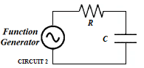Circuit A: A sinusoidal voltage of constant amplitude *V*0 = 3V and varying frequency is applied across a 100 ohm resistor and a 2.2 μF capacitor in series.
2. Calculate τ = *RC* and $ω_{1}=1/RC$ for this circuit and the fill in the table.

$τ=$_________s $ω_{1}=$_4550_rad/s $f_{1}=$___723____Hz

|  |  |  |  |  |  |  |  |
| --- | --- | --- | --- | --- | --- | --- | --- |
| $$\frac{ω}{ω_{1}}$$ $$\left(=\frac{f}{f_{1}}\right)$$ | Frequency (cycles/s = Hz) | Frequency  (radian/s) | $$X_{C}$$ (Ω) | R  (Ω) | $$I=\frac{V}{\sqrt{X_{C}^{2}+R^{2}}}$$ | $$V_{C}=IX_{C}$$ (V) | $$V_{R}=IR$$ (V) |
| 0 |  |  |  |  |  |  |  |
| 0.25 |  |  |  |  |  |  |  |
| 0.50 |  |  |  |  |  |  |  |
| 0.75 |  |  |  |  |  |  |  |
| 1.0 |  |  |  |  |  |  |  |
| 1.25 |  |  |  |  |  |  |  |
| 1.5 |  |  |  |  |  |  |  |
| 2.0 |  |  |  |  |  |  |  |
| 3.0 |  |  |  |  |  |  |  |
| 4.0 |  |  |  |  |  |  |  |
| 5.0 |  |  |  |  |  |  |  |

Plot your calculated *VC* and *VR* against $ω/ω_{1}$ in the space below. (Excel is your friend here.)

PLOT HERE

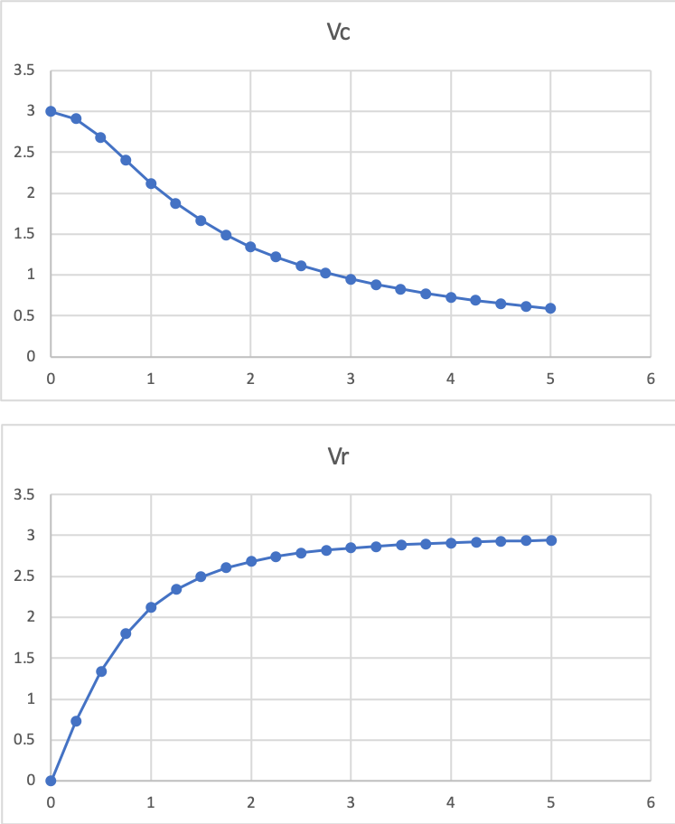

**RC Experiment**

**Equipment:** M1K board; Electronic Breadboard; Capacitor (2.2 μF), Resistor (100 Ω).

1. Preliminary information.
2. Record the values of your resistor (*R*) and capacitor (*C*):

*R =*___________ *C* __________

1. Calculate the angular frequency *ω*1 and the frequency *f*1 corresponding to 1/*RC* for your RC pair.

*ω*1 *=*___________rad/s *f*1 =____________Hz

* Set up the resistor *R* and capacitor *C* in series with the Ch A SVMI source as the function generator as shown in the diagram above. Use Ch B to measure the voltage at the center junction of the resistor and capacitor. An image of the set-up is given here.

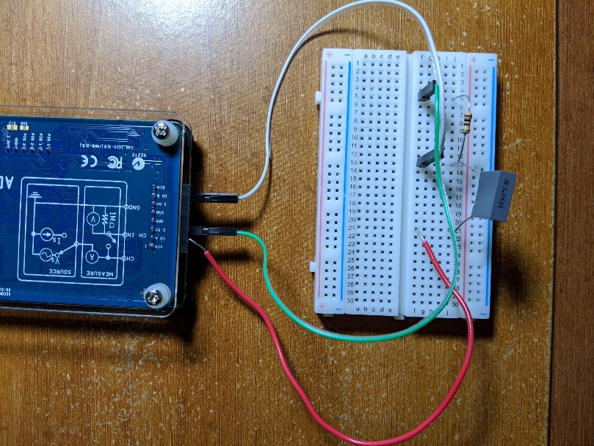

* Set up the ALICE oscilloscope using Ch A as the potential source.
  + Use the AWG Configuration Panel to set up the measurement channels.
    - AWG CH A
      * Mode = SVMI with Term = To 2.5
      * Shape=Sine; Freq Ch A = *f*1 from question 3 above.
      * Min Ch A = 1.0; Max Ch A = 4.0
      * Make sure the SYNC AWG Box at the bottom of the menu is unchecked.
    - AWG CH B to Hi-Z with Term=Open (This disconnects B from its source voltage. Other settings are unimportant.) Also, uncheck the Sync AWG box.
  + Here are suggested settings for getting started. You should vary them in order to optimize your view.
    - On the menus bar across the top of the oscilloscope frame
      * Curves menu, choose CA-V and CB-V
      * Trigger menu select CA V and Auto level.
      * Edge menu = Falling
      * Time mS/Div = 1.0 mS/Div
    - On the settings bar across the bottom of the oscilloscope select CA V/Div, CA V Pos, CB V V/Div, and CB V Pos to get both Channel A and Channel B Voltage on the screen with each signal filling most of the vertical range. (You will find it best to set the CA and CB V Position to 2.5 V.) Set the Time/div to get a few cycles on the screen.
  + Save the data to CSV.
* Import the data into a program such as Excel.
* Subtract 2.5 V from both channel A and channel B to set the center of the wave at 0 V.
* Create a new column with (ChA-ChB, i.e., the subtraction of ChB from ChA). This is the voltage across the capacitor.

4) Plot Ch A, Ch B, and (ChA-ChB) as functions of time displaying a few cycles of the signal and insert the plot here.

PLOT HERE

* On the right hand (CONN) menu panel in ALICE, select CA V P-P ($V_{pp}\left(A\right)$ measurement) and CB V P-P ( $V_{pp}(B)$ measurement). ( $V_{pp}\left(A\right)$ is the driving voltage. $V_{pp}\left(B\right)$ is the voltage across the resistor.) $\sqrt{V_{pp}{\left(A\right)}^{2}-V_{pp}{\left(B\right)}^{2}}$ is the voltage across the capacitor.

5) Fill in the table below by changing the Ch A frequency and measuring the Ch B peak to peak voltage for each frequency.

|  |  |  |  |  |  |
| --- | --- | --- | --- | --- | --- |
| $$\frac{ω}{ω_{1}}$$ $$\left(=\frac{f}{f_{1}}\right)$$ | Frequency (cycles/s =Hz) | Frequency  (radian/s) | Ch A $$V_{pp}(A)$$ (V) | Ch B $V_{pp}(B)$ (V) | $$\sqrt{V_{pp}{\left(A\right)}^{2}-V_{pp}{\left(B\right)}^{2}}$$ (V) |
| 0.25 |  |  |  |  |  |
| 0.50 |  |  |  |  |  |
| 0.75 |  |  |  |  |  |
| 1.0 |  |  |  |  |  |
| 1.25 |  |  |  |  |  |
| 1.5 |  |  |  |  |  |
| 2.0 |  |  |  |  |  |
| 3.0 |  |  |  |  |  |
| 4.0 |  |  |  |  |  |
| 5.0 |  |  |  |  |  |

6) a) Plot and $V_{C}=\sqrt{V_{pp}{\left(A\right)}^{2}-V_{pp}{\left(B\right)}^{2}}$ as functions of $\frac{ω}{ω_{1}}$ here:

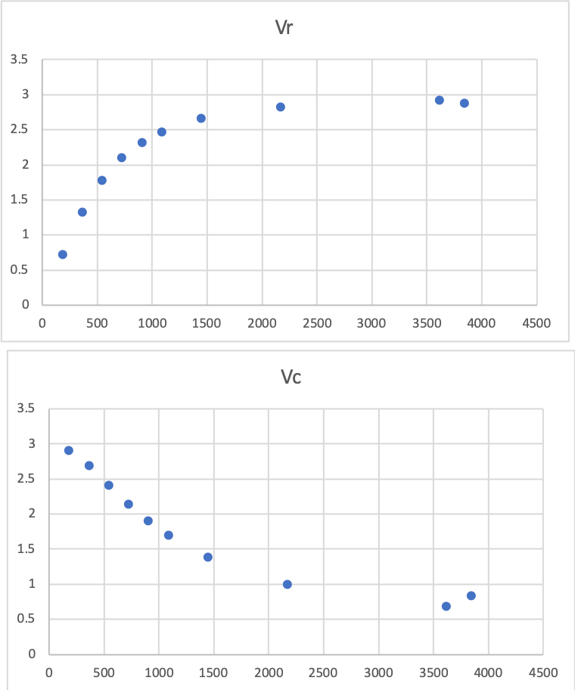PLOT HERE

7) Describe the behavior of $V_{pp}\left(B\right)$ and $\sqrt{V_{pp}{\left(A\right)}^{2}-V_{pp}{\left(B\right)}^{2}}$ as functions of frequency. Is this consistent with your plot in the model at the start of this section?

# Model and Experiment: LRC Circuit Model

8) A sinusoidal voltage of constant amplitude *V*0 = 3V and varying frequency is applied across a 100 ohm resistor, a 2.2 μF capacitor, and a 4.7 mH inductor in series.

9) Calculate $ω_{N}=1/\sqrt{LC}$ for this circuit and the fill in the table.

$ω_{N}=$_______rad/s *fN*=____________Hz

|  |  |  |  |  |  |  |
| --- | --- | --- | --- | --- | --- | --- |
| $$\frac{ω}{ω_{N}}$$ $$\left(=\frac{f}{f_{N}}\right)$$ | Frequency (cycles/s = Hz) | Frequency  (radian/s) | $$X_{C}$$ (Ω) | R  (Ω) | $$X_{L}$$ (Ω) | $$V_{R}=\frac{V_{0}R}{\sqrt{R^{2}+{{(X}_{C}-X_{L})}^{2} }}$$ (V) |
| 0 |  |  |  |  |  |  |
| 0.25 |  |  |  |  |  |  |
| 0.50 |  |  |  |  |  |  |
| 0.75 |  |  |  |  |  |  |
| 1.0 |  |  |  |  |  |  |
| 1.25 |  |  |  |  |  |  |
| 1.5 |  |  |  |  |  |  |
| 2.0 |  |  |  |  |  |  |
| 3.0 |  |  |  |  |  |  |
| 4.0 |  |  |  |  |  |  |
| 5.0 |  |  |  |  |  |  |

10) Plot your calculated *VR* against frequency in the space below. (Excel is your friend here.)

**PLOT HERE**

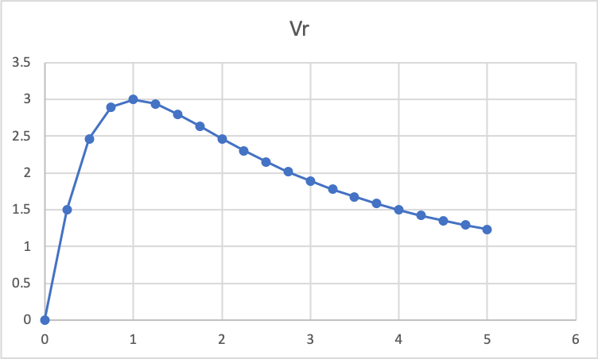

11) Describe the behavior of *VR* as a function of frequency.

**LRC Circuit Experiment**

**Equipment:** M1K board; Electronic Breadboard; Capacitor (2.2 μF); Inductor (4.7 mH); Resistor (100 Ω).

12) Estimate the natural frequency *f*N in Hz for this circuit using *your values for L and C.*

*fN =*__________________Hz

* Set up the RCL circuit shown above, consistent with the image below. Once again ChA serves as the source and Ch B serves to measure the voltage across the resistor.

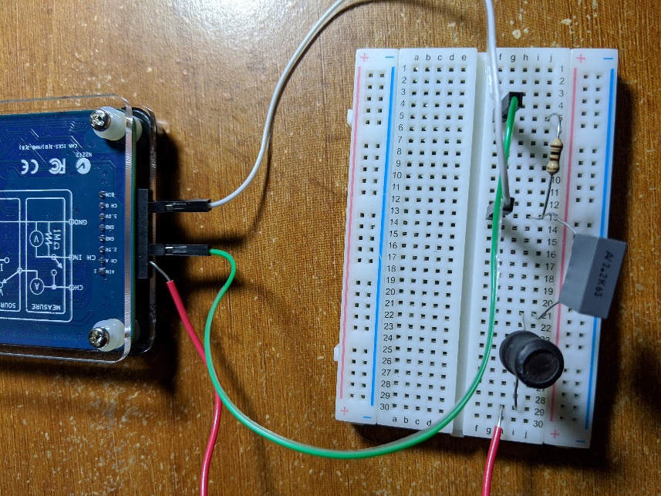

* Set the CH A frequency to *fN* .
* Set up ALICE as you did for the RC circuit above.

13) Fill in the table below by changing the Ch A frequency and measuring the Ch B peak to peak voltage for each frequency.

|  |  |  |  |  |
| --- | --- | --- | --- | --- |
| $$\frac{ω}{ω_{N}}$$ $$\left(=\frac{f}{f_{N}}\right)$$ | Frequency (cycles/s = Hz) | Frequency  (radian/s) | Ch A $$V_{pp}(A)$$ (V) | Ch B $V_{pp}(B)$ (V) |
| 0.25 |  |  |  |  |
| 0.50 |  |  |  |  |
| 0.75 |  |  |  |  |
| 1.0 |  |  |  |  |
| 1.25 |  |  |  |  |
| 1.5 |  |  |  |  |
| 2.0 |  |  |  |  |
| 3.0 |  |  |  |  |
| 4.0 |  |  |  |  |
| 5.0 |  |  |  |  |

14) Channel B is the peak to peak voltage across the reistor. It is a measure of the peak to peak current. Plot the Ch B voltage from the table above as a function of frequency.

PLOT HERE

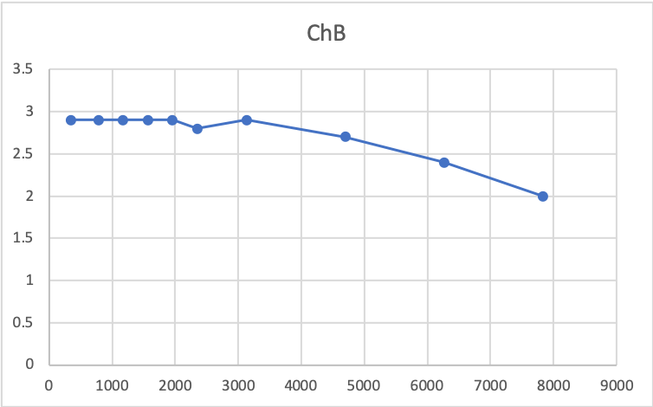

15) Describe the shape of the plotted data as a function of $ω/ω_{N}$. Is its behavior consistent with your model calculations in the previous section?